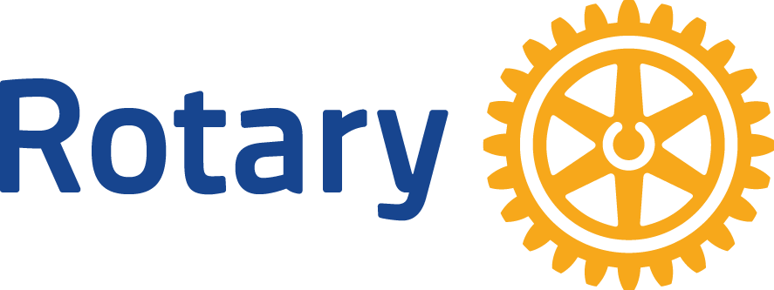October 16, 2023

Dear Valued Supporter:

It is with great excitement and pleasure that we inform you of the upcoming 36th Annual Rotary Auction, which will be held online from November 4th to 12th 2023.

Through the donation of auction items, your past generosity has enabled us to undertake many projects in the North Island. For example, the Rotary Family Fishing Park, equipment at the Rotary Centennial Playground, the Fort Rupert Library and Learning Centre, Rotary Pavilion at Storey's Beach, the Seniors Housing Complex in Port Hardy, the boat launches in Port Hardy, the North Island Born to Read Program, many parks, food programs, playgrounds, bus shelters, and other projects too numerous to mention. The North Island is also renowned for our support of the Rotary Youth Exchange Program, where we host foreign students in our homes and send local students from the North Island for one year stays in other countries.

All these projects and services are supported by our fundraisers, the largest of which is the Annual Rotary Auction. For thirty-five years this event has helped to generate funds which support important projects on the North Island and around the world. This year, our online format will ensure that bidding on the auction items will be easy and accessible to everyone in the North Island, and even beyond.

We are again asking for your support by donating an item to the Rotary Auction. Your donation will receive valuable exposure through our advertising and social media efforts, and we hope that our 2023 Rotary Auction will see the auction items exposed to the widest audience yet.

Thank you in advance for your continued support.

Yours truly,

Adam Ireton

President

Rotary Club of Port Hardy