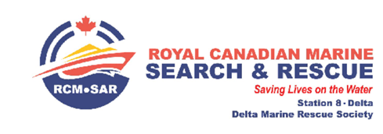

**Tour de Duck Race 2023 Fundraiser - Deas Island Regional Park on September 17th, 2023.**

We are writing to you on behalf of the Royal Canadian Marine Search and Rescue Station in Delta (RCM-SAR 8) to inform you of our upcoming major fundraising initiative; the **2023 Tour de Duck Race.** This will be our first Tour de Duck fundraiser since our successful event in 2018 prior to Covid 19 impacting our lives.

**Who is RCM-SAR 8:**

We are an **all-volunteer** organization dedicated to Saving Lives on the Water. We are tasked by the Joint Rescue Coordination Centre in Victoria to respond to emergency Search and Rescue situations in a general area of approximately 600 square miles of Georgia Strait north of the US border from our base in Point Roberts**.**

**How we are funded:**

RCM-SAR 8 is funded by the Delta Marine Rescue Society (DMRS), a registered non-profit charitable society formed to fund and raise funding for Marine Search and Rescue operations (SAR) in local waters. *To remain operational, it is necessary that DMRS annually raise approximately $50,000 in additional funding. We rely on Delta residents, businesses, and corporations to support us in raising these funds.* This support is critical to ongoing training, safety equipment and maintenance of our boat and systems.

**Tour De Duck 2023 and Prize Donations:**

The Tour de Duck race involves over four thousand rubber ducks, whose unique numbers will be purchased by members of the public and will “furiously” race down the Fraser River for a chance to win one of the generously donated prizes. This letter is requesting donations of prizes to attract duck “sales”.

For our major prize donors, your prize and company name will appear on all Tour De Duck posters, at local community events, and on our ticket sales website. You will also be included in our ‘Thank You’ ad in the Delta Optimist community newspaper and added to our Donors listing on our RCM-SAR website. Invoices or tax receipts will be provided upon request.

If you are able to provide a donation for us to use as a prize, please call or email our prize coordinator, Anne Kirkland, at 604-365-5847 or email [annekaloha@gmail.com](mailto:annekaloha@gmail.com) and she will arrange for a volunteer to pick up your generous prize offering. If you require any more information, please do not hesitate to contact us.

Thank you for considering this request, and we look forward to hearing back from you!

Anne Kirkland Craig Caplan

Director, Project Fundraising Station Leader - RCM-SAR 8

Delta Marine Rescue Society