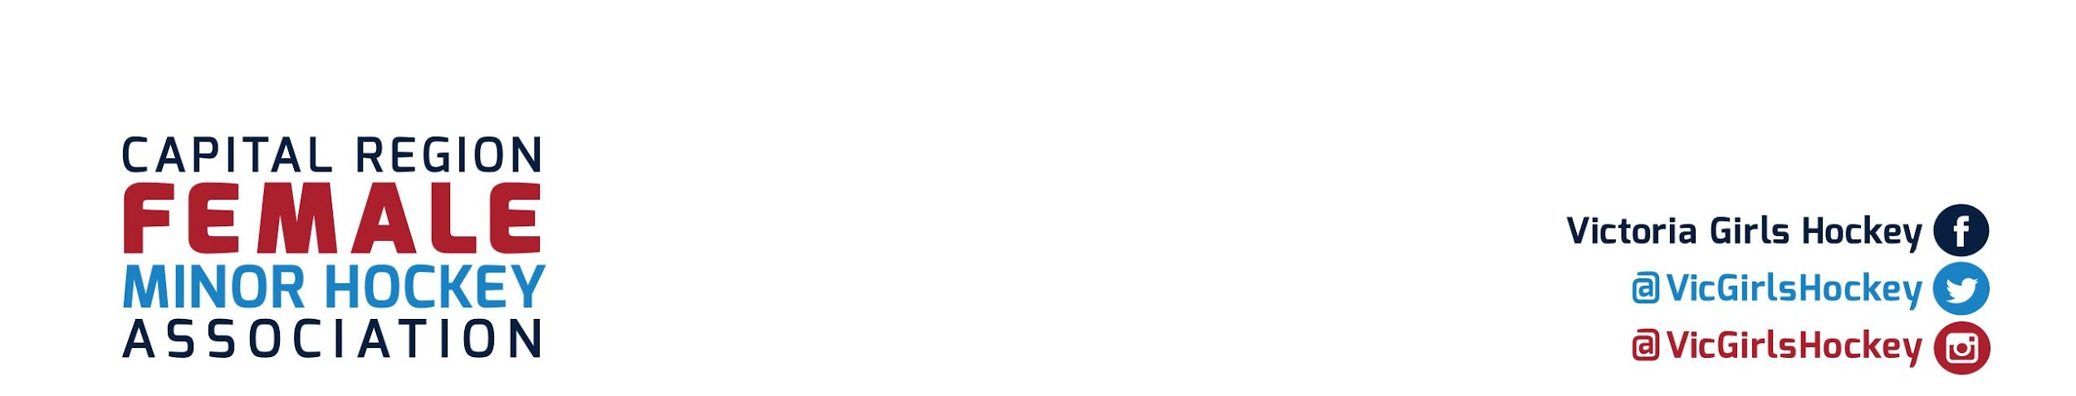

To Pacific Coastal Airlines

**Capital Region Female Minor Hockey Association** (CRFMHA) is a registered non-profit society that delivers all-female hockey programming for girls ages 5-20 years throughout the Capital Regional District.

**U11C Teams** are hosting an upcoming Remembrance Day tournament. The tournament takes place at Seaparc Leisure Complex, in Sooke, and runs from Friday November 11th to Sunday November 13th, 2022. We will be hosting 4 teams from Vancouver Island or the Mainland as well as 4 of our own local teams. Throughout the tournament, we are holding a silent auction and selling raffle baskets to parents, players, and supporters of all these teams. We are hoping to see a high turn-out of supporters and such.

To help support the cost of this tournament and other activities such as dryland training, traveling and ice rentals, our teams are seeking donations for our raffle and silent auction.

In exchange for your donation, we can offer recognition of the Pacific Coastal Airlines at our tournament, and donations of over $100 will have their business logos in the tournament program.

We hope you can help us.

Thank you in advance for your consideration from the 130+ female players and their families.

For any questions, please contact me.

Sincerely,

Shelly Urban

Team Manager U11-C1

shelly.joe@gmail.com