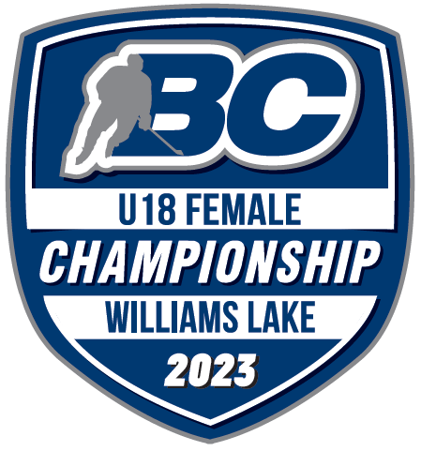 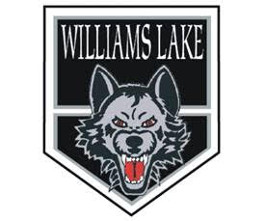

**WILLIAMS LAKE MINOR HOCKEY   
2023 BC HOCKEY U18 FEMALE**

**CHAMPIONSHIPS**

Dear Community Partner:

We are organizing the BC Hockey U18 Female Championships on behalf of the Williams Lake U18 Timberwolves. An amazing group of enthusiastic 15, 16 and 17-year-old female athletes who love to play competitive hockey. Over the last few years our teams have participated in these championships at various levels. In 2018 we successfully hosted and won GOLD with our Midget Female team. That game was attended by a packed crowd one of the largest groups I’ve ever seen for a minor hockey game here in Williams Lake. This year it’s our chance to do it again with the U18 Female team, and are looking to get sponsors from various community partners. Sponsorships received from Community Partners, such as you, are absolutely critical to the success of this event and helps us to pay for game related expenses such as, ice time, referee costs as well as travel cost for out of town officials.

We raise money during the event through 50/50 draws, a raffle table, with local baskets provided by participating teams and a small amount of apparel sales. We also get some funding from the City of Williams Lake and BC Hockey.

We are seeking sponsors who will support these Championships with a suggested starting commitment of $250.00. Your help would allow us to continue in our pursuit of high-performance hockey events here in Williams Lake, and hope to inspire future generations of hockey players with the level of play this event brings to Williams Lake.

We plan to recognize our sponsors in the following ways:

* Announcing your business as a sponsor of the game including any catch phrase during the game
* Your Company’s name and logo displayed on a banner at the Championships Mar 23rd to 26th
* Your Company’s name, logo, and contact information placed in any program

Sponsors not only benefit from this advertising, but will also have the knowledge that they are contributing to the success of young competitive hockey players not just this year but for years to come.

Game specific sponsorships are available, the base commitment ensures your business will be mentioned several times during one of the games during the championships. Below are other options:

Home Game during the day - $500 Home Game during the evening - $750 Gold Medal Game - $1500

If you are interested in our sponsorship program, please contact me at the number below. Cheques can be made payable to “WLMHA”.

Our coaches, players, association and the organizing committee would like to take this opportunity to thank you very much for your generosity and support!

Yours truly,

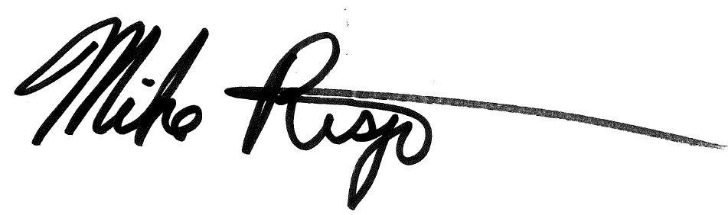

Mike Rispin

Championships Chair, Host Committee

[mdrispin@gmail.com](mailto:mdrispin@gmail.com)

250-267-3667